COMPLETE BLOOD/BLOOD GAS ANALYSER
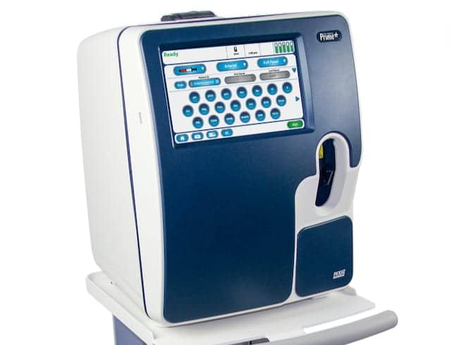
Introduction
The pH value of blood, serum or plasma is an indicator of the balance between the blood, renal (kidney), and lung (respiratory) systems, and is one of the most tightly controlled parameters in the body.
The pCO2 value of arterial blood is used to assess how well the body eliminates carbon dioxide, a by-product of metabolism.
The pO2 value of arterial blood is a measure of how well the body is able to absorb oxygen in the lungs. Electrolytes and metabolites give further information about body chemistry.
An arterial blood gases (ABG) test is a blood test that measures the acidity, or pH, and the levels of oxygen (O2) and carbon dioxide (CO2) from an artery. The test is used to check the function of the patient’s lungs and how well they are able to move oxygen into the blood and remove carbon dioxide.
An ABG is one of the most commonly used tests to measure oxygenation and blood acid levels, two important measures of a patient’s clinical status and correct interpretation can lead to quicker and more accurate changes in the plan of care. It's commonly performed in the ICU and ER setting; however, ABGs can be drawn on any patient on any floor depending on their diagnosis.
According to the National Institute of Health, typical normal values of PH, PO2, and PCO2 are:
- PH: 7.35-7.45
- Partial pressure of oxygen (PO2): 75 to 100 mmHg
- Partial pressure of carbon dioxide (PCO2): 35-45 mmHg
- Bicarbonate (HCO3): 22-26 mEq/L
- Oxygen saturation (O2 Sat): 94-100%

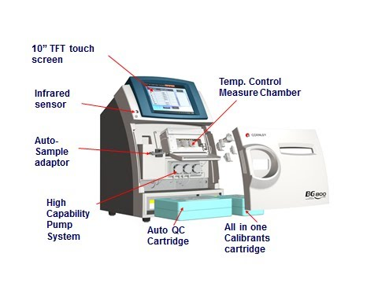

Blood gas analyzers are designed to measure pH, pCO2 (carbon dioxide gas pressure) and pO2 (oxygen gas pressure) from a single sample of whole blood. The size of the sample may vary from 25 μl to a few hundred microliters.
The analysis of pH helps in determining Acid-Base balance and that of pCO2 and pO2 helps in determination of respiration exchange within the blood.
The analysis is also used in calculating other parameters like Bicarbonates, oxygen saturation, base excess and carbon dioxide.
The main features of the modern analysers are;
- Microprocessor control of all functions
- Temperature control of electrodes
- Automatic self-calibration and self-checking system
- Display of results
- Automatic print out of results
- Automatic flushing after completion of each test
WORKING PRINCIPLE
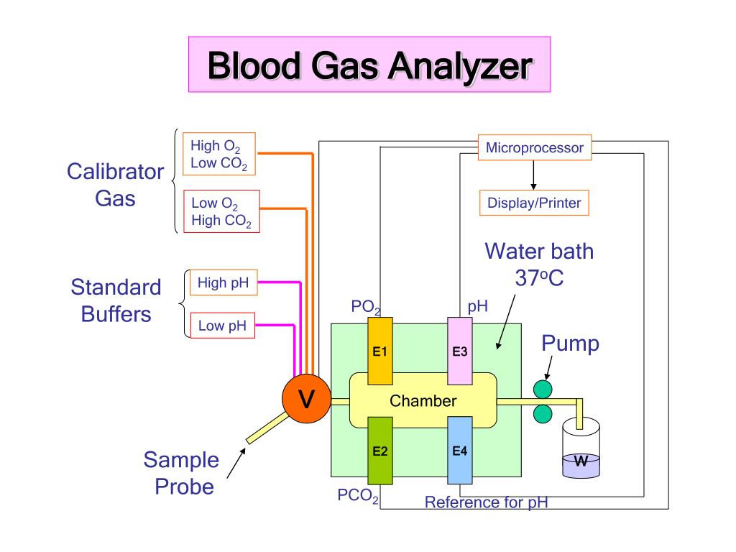
The blood-gas analysers consist of a voltmeter and a thermostatically controlled electrode system.
Blood is collected from the patient and introduced into the analyser. The analyser aspirates the blood into a measuring chamber which has Ion Selective Electrodes (IE electrodes that are sensitive only to the measurement of interest).
The pH electrode compares a potential developed at the electrode tip with a reference potential, the resulting voltage is proportional to the concentration of hydrogen ions, [H+].
The pCO2 electrode is a pH electrode with a Teflon or silicone rubber CO2 semi permeable membrane covering the tip.
CO2 combines with H2O in the space between the membrane and the electrode tip to produce free hydrogen ions in proportion to the partial pressure of CO2.
The voltmeter, although actually measuring [H+], is calibrated in pCO2. For pO2, oxygen permeates a polypropylene membrane and reacts chemically with a phosphate buffer.
The O2 combines with water in the buffer, producing current in proportion to the number of oxygen molecules. The current is measured and expressed as partial pressure of oxygen.
After measurement, the blood is automatically expelled into a waste container and the sample path is cleaned, ready for the next sample. Results may be printed, displayed and sent to the Laboratory Information System.
Many of the blood gas analysers have a provision for checking the membrane of pO2 and pCO2 electrodes. In the check position, a potential is applied across the membrane.
Any leak in the membrane of sufficient magnitude will result in a considerable lowering of the resistance may be from 100 MW to 500 kW.
Block diagram of a complete blood gas Analyser
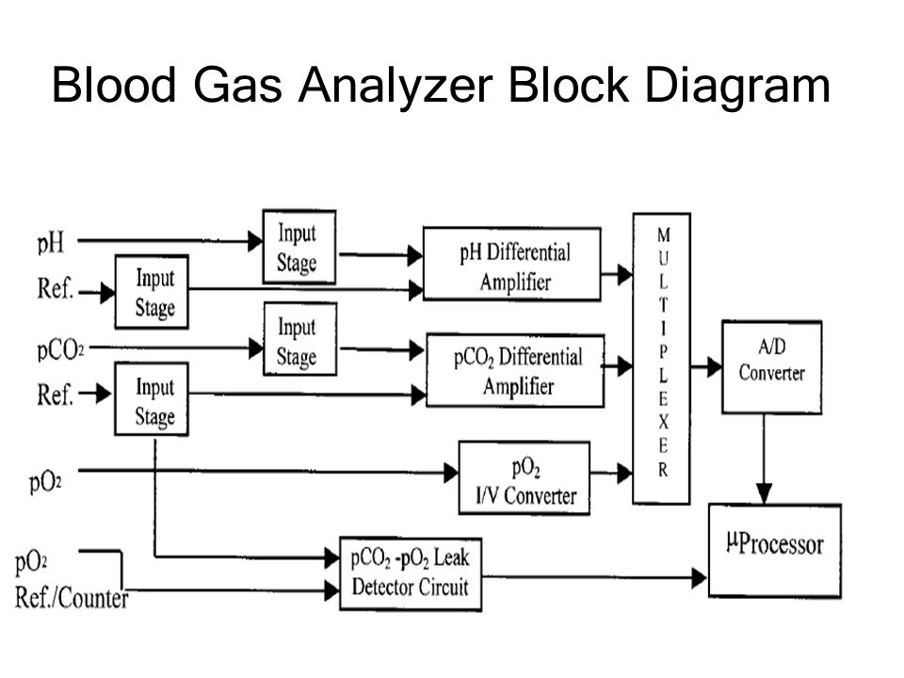
The outputs from multiple sensors and calculators are driven through a multiplexer to an analog-to-digital converter (ADC).
The data is processed in the microcontroller, which is connected to a PC or other instruments through RS-232, USB, or Ethernet. A digital-to-analog converter (DAC) is often used to calibrate the sensor amplifiers to maximize the sensitivity of the electrodes.
Modern blood gas analysers increasingly employ a touch screen in combination with a graphical user interface (GUI) to make the programming process more intuitive.
The instrument contains three separate high input impedance amplifiers designed to operate in the specific range of each measuring electrode.
A separate module houses and thermostatically controls the three electrodes. It also provides thermostatic control for the humidification of the calibrating gases.
A vacuum system provides aspiration and flushing service for all three electrodes.
Calibrating gases are selected by a special push button control and passed through the sample chamber when required. Two gases of accurately known O2 and CO2 percentages are required for calibrating the analyser in the pO2 and pCO2 modes. The gases required are: O2 value of 12% Cal and 0% Slope and CO2 value of 5% Cal and 10% Slope. These gases are used with precision regulators for flow and pressure control.
Two standard buffers of known pH are required for calibration of the analyser in the pH mode. The buffers that are used are 6.838 (Cal) and 7.382 (Slope). It is generally recommended that the sample chamber should control 7.382 buffers when in the standby mode.

Types of Electrodes Used in Blood Gas Analysers
- pH Electrode
Unlike in the ordinary PH meter electrode, this type of electrode is not dipped into the sample. Instead the glass electrode contacts the blood on the inner surface of a capillary glass tube.
This arrangement enables analysis of small volumes, avoids contacts with surrounding atmosphere and enables attainment of rapid thermostatic (temperature) equilibrium.
The electrode circuit is completed using a calomel reference electrode via a liquid or fibrous potassium chloride junction or through a membrane.
- pO2 Electrode
This consists of a very fine platinum wire cathode maintained at a specific potential (normally at 650mV) at which oxygen molecules are reduced and separated from the blood sample a thin propylene membrane. Oxygen from the sample diffuse through the cathode by electrons drawn from a silver anode.
The rate of oxygen diffusion depends on the oxygen tension (partial pressure) in the blood and this in turn determines the rate of reduction hence the rate of electron transfer from the anode.
The process of electron transfer results in an electric current flow in a micro ampere proportional to the partial pressure of oxygen (pO2) in the blood sample.

- pCO2 Electrode
A pCO2 Electrode is essentially a pH electrode whose active glass surface is separated from the blood sample by a membrane that is permeable to uncharged molecules but will not allow passage of charged particles such as hydrogen ions.
The typical membrane materials are silicon, rubber and Teflon. Behind the membrane is a porous spacer, usually paper or synthetic fabric that holds a layer of bicarbonate buffer.
As the CO2 molecules diffuse through the membrane, they react with bicarbonate buffer producing a small change in the pH. The rate of this change depends on the rate of CO2 diffusion which is proportional to the partial pressure CO2 (pCO2) dissolved in the blood sample.
Bicarbonate Determination
The measured values of pH and pCO2 are used in the following equation (Henderson-Hasselbalch Equation) to calculate the bicarbonate content;
Bicarbonate = Antilog (pH – pKa + log (Carbonic Acid))

